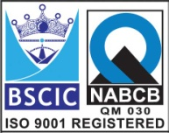****

**“EASCO” Wafer Type Butterfly Valve Gear Operated**

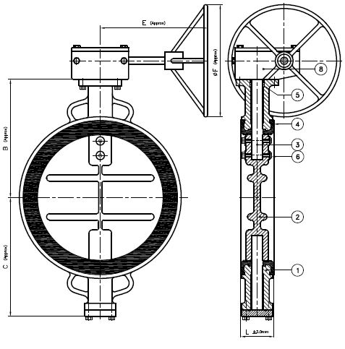

**Features: -**

* Zero Leakage
* Leak Tight Shut Off
* Lower Torque
* Smooth Operation & Installation
* Long Life
* Available in PN10 / PN16

**Testing Standard: - BS 6755**

|  |  |  |
| --- | --- | --- |
| Test Pressure in PSIG | | |
| Test | Hydrostatic | Hydrostatic  PN 16 |
| Pr. Rating | PN 10 |
| Body | 340 | 425 |
| Seat | 230 | 300 |

**Part List: - Standard Dimension : -**

|  |  |  |  |  |  |  |  |  |  |  |  |  |
| --- | --- | --- | --- | --- | --- | --- | --- | --- | --- | --- | --- | --- |
| **No.** | **Part Name** | **Materials** |  | **Size** | **500** | | **600** | **700** | **750** | **800** | **850** |  |
| 01 | Body | IS 210 Gr. FG 200 / Ductile Iron  A 216 Gr. WCB / CF8 / CF8M | L | 127 | | 154 | 229 | 229 | 241 | 241 |  |
| B | 405 | | 540 | 565 | 590 | 590 | 610 |  |
| 02 | Disc | IS 210 Gr. FG 200 / Ductile Iron  A 216 Gr. WCB / CF8 / CF8M | C | 370 | | 460 | 515 | 540 | 650 | 675 |  |
| E | 350 | | 350 | 380 | 380 | 395 | 395 |  |
| 03 | Stem | AISI 410/304/316 | ǾF | 500 | | 600 | 500 | 600 | 600 | 600 |  |
| 04 | Body Seat (Liner) | Neoprene / EPDM / Nitrile / Silicon / Viton / Other Request | ISO 5211  Flange | F16 | | F16 | F16 | F16 | F25 | F25 |  |
|  |
| 05 | Gland Seal | Neoprene / EPDM / Nitrile / Silicon / Viton / Other Request |  |  |
|  | | | | | | | | | |
| 06 | Disc Lock Pin | SS 304/316 |
| 07 | Gear Box | Worm & Gear Type |
| 08 | Fasteners | CS / SS304 / SS316 |
|  | | | | | |

**Due to continuous development Program, the design & data given in this leaflet are subject to change without prior notice.**

**ANITA ENGINEERING WORKS**



58-59, Narayan Estate, Opp. Shree Ram Estate, Nr. CMC Ltd. Odhav, Ahmedabad-382415, Gujarat, India

Phone: +91 79 22974101, Fax: +91 79 22875014

Email: eascovalves@gmail.com, eascovalves@yahoo.com, Web: [www.eascovalve.com](http://www.eascovalve.com)